Statistics 140 Winter 17

Hand-In Assignment #3

Sarah Ruckman

Last 4 Digits of SID: 7194

1. The merle color seems to be a trademark for Australian Shepherds. Non-merled Aussies are often mistaken for other breeds. The merle gene is an incomplete dominant gene - NOT a simple recessive. This gene is also completely separate from the color genes (black, red, tan, white, etc.). Two solids bred together will produce all solids. One solid dog bred to one merle dog will produce 50% merles and 50% solids. Two merles bred together will produce 25% solids, 50% merles, and 25% lethal-white (double-merle). A dog with one merle gene and one solid gene will be a normal merle dog. A dog with two solid genes will be a solid (black or red). A dog with two merle genes will be a double-merle (a.k.a. homozygous merle, lethal white, excessive white, or lethal merle). The double-merle dogs are usually predominantly white, and most often are hearing impaired and/or visually impaired. There is some controversy as to whether these double-merle Australian Shepherds are also more prone to develop various genetic diseases such as auto-immune disorders than the solid or normal merle Australian Shepherds. A random sample of Australian Shepherd dogs was selected and cross-classified according to coloration and presence or absence of auto-immune disorders.The data is as follows:

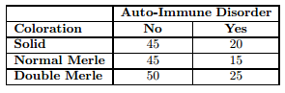

Perform the appropriate test of hypothesis to determine whether there is a relationship between coloration and presence/absence of the auto-immune disorders. Use α = 0.05.

**H0: No significant relationship between auto-immune disorder and coloration**

**Ha: Significant relationship between auto-immune disorder and coloration**

R Code:

> aussies<-read.table("C:\\Users\\Sarah\\Downloads\\aussies.dat", header=TRUE)

> aussies

NO YES

1 45 20

2 45 15

3 50 25

> chisq.test(aussies)

Pearson's Chi-squared test

data: aussies

X-squared = 1.1294, df = 2, p-value = 0.5685

**TS: X2 = 1.1294 with p-value = 0.5685**

**Since the p-value of 0.5685 is greater than α = 0.05, we do not reject H0**

**There is insufficient evidence to conclude that there is a significant relationship between coloration and auto-immune disorders in Aussies.**

1. A production plant currently runs two shifts: the day shift and the night shift. Brandon, a quality control engineer at the plant, was concerned about the number of equipment failures that were causing a shutdown of the production line. He was concerned that the number of breakdowns might be related to the shifts. (In other words, he was concerned that one shift might have a higher probability of a breakdown that the other.) He selected a random sample of 24 days and recorded the following data (measured in # of days):

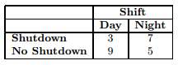

Perform the appropriate test of hypothesis to determine whether shift and production line shutdowns are independent. Test using α = 0.05.

**H0: Shift and production line shutdowns are independent**

**Ha: Shift and production line shutdowns are not independent**

R Code:

> quality1<-read.table("C:\\Users\\Sarah\\Downloads\\quality1s_w17.dat", header=TRUE)

> quality1

Day Night

1 3 7

2 9 5

> fisher.test(quality1)

Fisher's Exact Test for Count Data

data: quality1

p-value = 0.2138

alternative hypothesis: true odds ratio is not equal to 1

95 percent confidence interval:

0.02837295 1.76041409

sample estimates:

odds ratio

0.2539598

**TS: p-value = 0.2138**

**Since the p-value = 0.2138 is greater than α = 0.05, we do not reject H0**

**There is sufficient evidence to indicate shift and production lines are independent.**

1. A study was conducted to examine the number of equipment failures that were causing shutdowns of production lines at three production plants. The plants currently run two shifts: the day shift and the night shift. Quality control engineers were concerned that the number of breakdowns might be related to the shifts at the production plants. (In other words, they were concerned that one shift might have a higher probability of a breakdown than the other.) They selected a random sample from each plant and recorded the following data (measured in # of days):

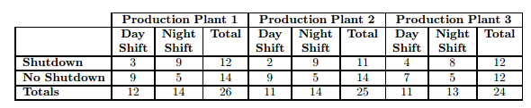

Perform the appropriate test of hypothesis to determine whether shift and production line shutdowns are independent. Test using α = 0.05.

**H0: Shift and production line shutdowns are independent**

**Ha: Shift and production line shutdowns are not independent (there is a relationship)**

SAS Code:

options ls = 78 ps = 55 nocenter nodate;

data mhtest;

infile 'C:\Users\Sarah\Downloads\quality2s_w17 (2).dat' firstobs = 2;

do plant = 1 to 3;

if plant = 1 then plant1 = 'Plant1';

else if plant = 2 then plant1 = 'Plant2';

else plant1 = 'Plant3';

do shift = 1 to 2;

if shift = 1 then shift1 = 'Day ';

else shift1 = 'Night';

do oper = 1 to 2;

if oper = 1 then oper1 = 'Shutdown ';

else oper1 = 'No Shutdown';

input wt @@;

output;

end;

end;

end;

proc print;

proc freq;

weight wt;

tables plant1*shift1*oper1/norow nocol cmh;

run;

quit;

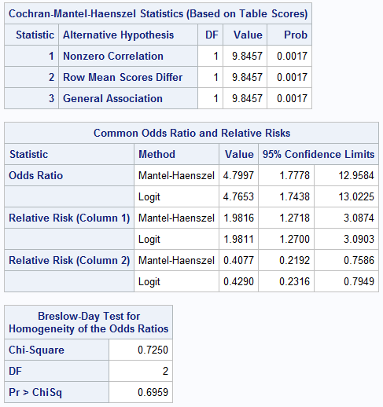

**TS: p-value = 0.0017**

**Since the p-value = 0.0017 is less than α = 0.05, we reject H0**

**There is sufficient evidence to indicate a relationship between shift and production line shutdowns.**